SiCheng Yi

Tesla's Business Model and Competitive Analysis

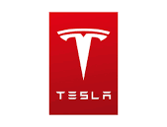

Abstract:

Tesla is the market leader in the electric vehicle and renewable energy solution industry, with a valuation surpassing several trillion dollars. Delve into the factors that allow this company's business model to dominate in its niche market and examine how this tech titan stands out in a fiercely competitive landscape.

Table of Contents

INTRODUCTION 1

BUSINESS MODEL 1

PETER’S FIVE FORCES 6

PEST ANALYSIS 8

COMPETITIVE STRATEGIES 9

BUSINESS MODEL EVOLUTION 9

IT SUPPORT PROPOSAL 10

WORK CITED 11

## INTRODUCTION

This article delves deeply into Tesla's business model, analyzing its competitive position in the market and the strategic measures it has adopted. The focus is primarily on how Tesla, with its advanced technology and continuous innovation, has managed to dominate the electric vehicle and renewable energy sectors. Furthermore, we will also discuss the current status of Tesla and explore how it strategically employs technology to address emerging market challenges.

## BUSINESS MODEL

Tesla, Inc. is an innovation-driven company, specializing in electric vehicles, solar energy products, and energy storage solutions. Tesla is not just a car manufacturer; it's also a technology company offering sustainable energy solutions to people worldwide. Tesla operates on a global scale, employing tens of thousands, with revenues surpassing $814.62 billion as of 2022(Tesla, 2023). Founded in 2003, the company is headquartered in Palo Alto, California. Tesla's business model incorporates both direct and online sales. Its flagship products include the Model S, Model 3, Model X, and Model Y, all emphasizing performance, safety, and sustainability. Tesla's innovation extends beyond its vehicles; its solar and energy storage solutions are also making significant contributions to the global energy transition.

**Market Model**

Tesla's market approach hinges on three pillars: its unique sales strategy, dedicated service, and expansive charging infrastructure.

Firstly, Tesla diverges from the traditional automotive sales channel of global dealerships by advocating a direct-to-consumer model. This entails that every Tesla store operates as a direct arm of the company itself, ensuring that customers engage directly with employees who represent the manufacturer.

Such a model empowers Tesla to refine its offerings through immediate feedback from its clientele and provide a bespoke service experience. This includes the ability to tailor-make vehicles online. To complement its sales strategy, Tesla has service hubs in every region where their cars are sold. Notably, they offer a standout 'Tesla Ranger' service where technicians make house calls.

Accompanying this, these hubs also facilitate charging. More pivotal, however, is Tesla's expansive Supercharger network, which lets vehicles juice up almost completely within 30 minutes. While these three facets are central to Tesla's market strategy, the product itself also stands apart. Tesla's cars are heralded for their unrivaled speed, extended range, distinctive design, and unmistakable brand identity.

Figure1: 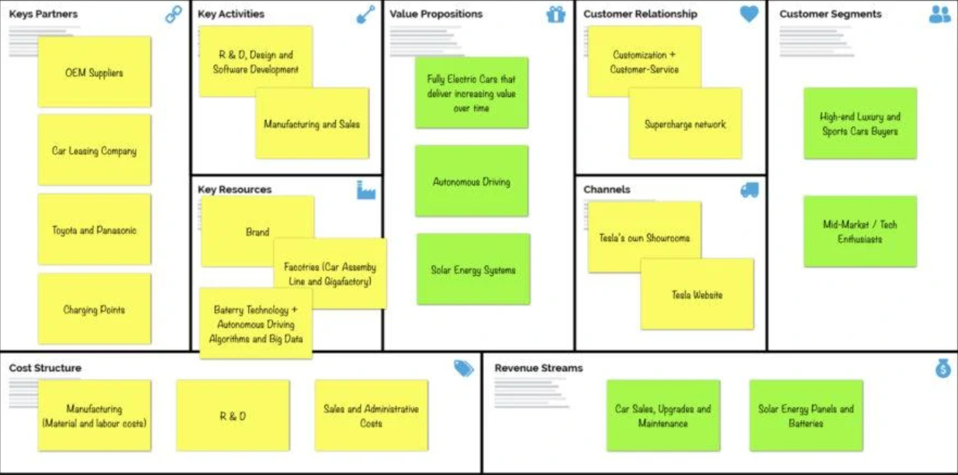

Figure 1: The Business Model Canvas of Tesla (Pereira, 2023)

Lastly, there's the comprehensive research and development process that the company undertakes. Tesla invests heavily in both hardware and software, with a particular emphasis on digital technology and even autonomous driving. Additionally, its growing commitment to reducing carbon emissions through investments in sustainable energy has garnered governmental backing.

This almost entirely self-sustained ecosystem positions them ahead of their competitors.

Figure 2:

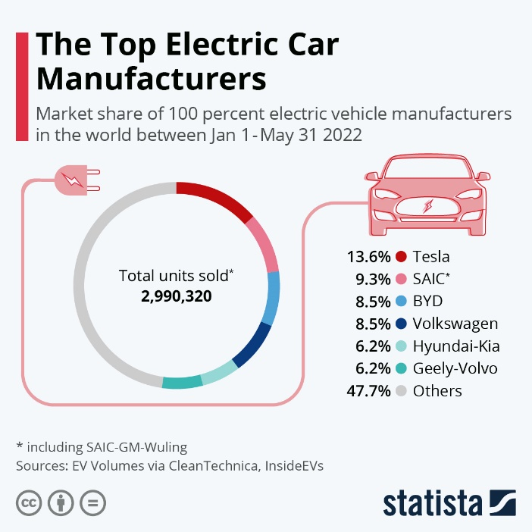

Figure 2: In 2022, Tesla remains the leader in the electric vehicle industry（Fleck, 2022)

**Financial Model**

Tesla, Inc., in 2021, boasted impressive financial metrics, underpinning its dominance in the electric vehicle sector. The company reported a net income of $5.5 billion, representing 21% of its total revenue of $31.5 billion. This substantial increase in net income contrasts starkly with $0.9 billion in 2020 and $0.5 billion in 2019. Tesla's market capitalization reached a staggering $650 billion, ending the fiscal year 2021 with a cash position of $19.4 billion (Financial Modeling Prep, 2021). This cash position originated from $15 billion of operational cash flow, making up 77% of the positive cash flow, with an investment cash flow of $3.8 billion. The remaining 23% was carried over from 2020's cash position of $14.5 billion. The investment cash flow for the fiscal year 2021 was a negative of $11 billion.

Tesla trades on the NASDAQ with the ticker TSLA. Opting for reinvestments over shareholder dividends, Tesla funnels resources back into its operations and growth strategies (Tesla, 2021). Their gross profit stood at $11.5 billion with a cost of revenue at $20 billion. Operational expenses are itemized into categories such as marketing and sales, research and development, and general & administrative, tallying up to $9.7 billion for the year. The operational profit amounted to $1.8 billion, with an additional $9.2 billion generated from tax reliefs and strategic investments.

Tesla's solutions target the entire automotive market spectrum, from luxury to more affordable segments. Automotive sales represent 86% of the company's total revenue, with the remaining 14% sourced from energy products, services, and other operations (Tesla, 2021). The automotive revenue is further subdivided into Model S/X, Model 3/Y, and the upcoming Cybertruck and Roadster. The Model 3/Y category has been the major revenue driver, addressing the mass market's demands. Products in this segment focus on offering sustainable transport with a blend of performance, range, and affordability. Its year-on-year growth is particularly noticeable, attributed to Tesla ramping up production and expanding into international markets.

**Operating Model**

Tesla's business strategy revolves around a trifecta approach to selling, servicing, and charging its electric vehicles:

1. Direct Sales

Unlike conventional automakers that use franchised dealerships, Tesla sells directly to consumers. They've established a global network of company-owned showrooms and galleries, predominantly located in urban centers.

Tesla believes that owning the sales channels gives them an edge in the speed of product development. More crucially, it offers a superior customer purchasing experience. Unlike car dealerships, Tesla showrooms have no underlying profit motives clashing. Customers interact solely with Tesla-employed sales and service personnel.

By May 25, 2022, Tesla had a global presence with 823 spots, which includes showrooms, combined retail and service centers known as Service Plus locations, and other service facilities. Moreover, Tesla embraces digital sales, allowing consumers to customize and order their vehicles online.

2. Home Service

In select regions, Tesla employs mobile service teams, previously referred to as Tesla Rangers. These technicians provide door-to-door service. Sometimes, the service is even remote. The Model S, for instance, can wirelessly relay data, enabling technicians to diagnose and even fix certain issues without physically interacting with the car. (Zucchi, 2022)

3. Supercharger Network

Tesla has built its own network of over 30,000 superchargers globally, letting drivers charge their Tesla vehicles in roughly 15 minutes at a cost that's a fraction of gasoline prices. The objective is clear: to promote EV adoption by making them more economical and convenient to operate. (Zucchi, 2022)

**Competitive Model**

Established car manufacturers are broadening their portfolios with hybrids and fully electric models, like Nissan's Leaf. Intriguingly, in the vast Chinese market, where Tesla's name rings a bell for many, it only accounts for 6.6% of the EV market share.

As the industry blooms, rivals are intensifying their production and sales strategies. According to data from Fortune Business Insights, the global EV market is projected to grow at an impressive 24.3% annually, skyrocketing from $287.36 billion in 2021 to a whopping $1.3 trillion by 2028.

Yet, regardless of its market position, Tesla boasts a formidable brand recognition. It thrives on persistent word-of-mouth publicity and possesses a competitive edge in terms of features:

Tesla, when talking about autonomous driving, has arguably collected data from approximately 2 billion miles through its Autopilot driver assistance system. This vast pool of data is believed to be, and likely will be, enhancing Tesla's self-driving algorithms.

Tesla's batteries consistently deliver longer driving ranges for their cars than most rivals. The Tesla Model S, for instance, boasts a range of 405 miles. (Cheng, 2022)

Maintaining a hefty slice of the market is key for any brand's competitiveness. Among the EVs Tesla rolls out, four have carved a niche in the market share. The frontrunners as of October 2022, with their respective market percentages for Q2, include:

1. Model Y from Tesla (30.4%)

2. Model 3 from Tesla (27.8%)

3. Ford's Mustang Mach-E (5.6)

4. Model S from Tesla (4.6)

5. Hyundai's IONIC 5 (3.8%)

Tesla's relationship with cloud computing can be characterized in the following ways:

1. Data Storage and Analysis: Tesla vehicles generate vast amounts of data, ranging from driving behaviors to vehicle performance. This data needs to be stored somewhere and analyzed. By utilizing cloud computing platforms, Tesla can store this data quickly and securely and employ sophisticated analytical tools to interpret it, optimizing vehicle performance or enhancing customer experience.

2. Software Updates: Tesla vehicles regularly receive over-the-air software updates, which can improve vehicle functionalities, fix bugs, or add new features. These updates are deployed through cloud servers and then pushed to each car.

3. Autonomous Driving and AI: Tesla's autonomous driving technology requires substantial data for training and refinement. Cloud computing offers Tesla the computational power needed to process this data and train its AI models.

4. Energy Services: Tesla isn't just a car company; it offers solar solutions and home batteries. These products also generate data, and Tesla can use cloud computing to manage and optimize this data to provide more efficient energy solutions.

5. Vehicle Connectivity: Tesla's vehicles are highly connected, allowing real-time communication with external servers and other devices. Cloud computing platforms support this continuous flow of data.

In summary, cloud computing provides Tesla with a robust, flexible, and scalable platform that allows it to store, analyze, and share vast amounts of data, underpinning its products and services.

## PETER’S FIVE FORCES

Porter's Five Forces drive a company's business decisions by highlighting its strengths, weaknesses, opportunities, and threats. Therefore, recognizing these factors is essential for successfully propelling a business forward.

**Threat of sunstitute**

For Tesla, the threat of substitutes is the lowest among the five competitive forces. Here's why Tesla isn't overly concerned about the threat of substitutes:

1. Unique Product Positioning: Tesla is more than just an electric car manufacturer; it embodies a high-end, innovative, and eco-friendly lifestyle. This distinct brand positioning makes conventional gasoline cars or traditional hybrids hard to be seen as true alternatives to what Tesla offers.

2. Technological Leadership: Tesla's advancements in autonomous driving, battery technology, and software update capabilities give it a competitive edge. While there are other electric vehicles on the market, they struggle to offer a holistic experience comparable to Tesla's.

3. Charging Infrastructure: Tesla has established a vast Supercharger network, ensuring convenient charging for its electric vehicles. Users of other electric vehicle brands might find it challenging to locate adequate charging facilities in certain areas.

4. Total Cost of Ownership: Considering that charging costs are much lower than traditional gasoline expenses, lower maintenance costs for electric vehicles, and potential government incentives, Tesla's electric vehicles prove to be cost-effective in the long run.

5. Environmental Awareness: As consumers become more environmentally conscious, electric vehicles are perceived as a greener mode of transportation. This diminishes the appeal of fuel-based vehicles as substitutes.

Hence, even with competition from other brands in the electric vehicle market, Tesla's distinctiveness in multiple areas reduces the threat from potential substitutes.

**Bargaining Power of suppliers**

Tesla's bargaining power over its suppliers is notably strong, primarily due to its vertical integration strategy, producing many components in-house. The company's diverse supplier base further dilutes any single supplier's influence. With Tesla's increasing production volumes, it benefits from economies of scale, giving it an advantageous position in negotiations. The specialized nature of Tesla's parts, combined with strategic long-term partnerships, further reduces suppliers' leverage. Thus, while suppliers play a crucial role in Tesla's operations, their ability to exert significant influence over Tesla is limited.

**Bargaining Power of Buyers**

The bargaining power of buyers impacts Tesla to a certain extent, influenced by several factors. As electric vehicles become more mainstream, consumers have a growing range of options to choose from, which increases their bargaining power. Additionally, the high price point of Tesla vehicles, especially when compared to emerging competitors offering more affordable EVs, empowers buyers further. While Tesla's distinct brand and product differentiation offer a competitive edge, informed consumers are becoming increasingly aware of comparable alternatives. Lastly, the EV market's dependency on government incentives also indirectly enhances the buyer's position, as these incentives significantly affect the final price consumers pay. In summary, while Tesla has built a robust brand reputation and loyal customer base, the evolving EV landscape is gradually amplifying the bargaining power of buyers.

**Threat of New Entrants**

The threat of new entrants exerts significant pressure on Tesla, primarily due to the following reasons:

The electric vehicle market has witnessed substantial growth and potential, attracting a multitude of players, from startups to established automakers, to invest and compete in this space. As technological advancements become more accessible and battery prices decrease, the barrier to entry in the EV sector diminishes. Established automakers with vast resources, distribution networks, and manufacturing capabilities are pivoting towards EV production, thereby intensifying competition. Moreover, countries and regions globally are setting ambitious targets to phase out internal combustion engines, further incentivizing new players to enter the market. Lastly, the allure of the EV market, combined with the proliferation of shared and autonomous mobility concepts, encourages tech companies and other non-traditional automotive players to explore opportunities in this arena.

In summary, the booming potential of the EV industry, coupled with decreasing entry barriers and the strategic shifts of massive corporations towards electrification, amplifies the threat of new entrants for Tesla.

**Competitive Rivalry**

Competitive rivalry poses the most significant challenge for Tesla, and here's why:

The electric vehicle market is no longer a niche segment; it's rapidly transitioning to the mainstream. As a result, many established automakers, such as Volkswagen, General Motors, and BMW, are pouring billions into R&D, aiming to secure a substantial share of the burgeoning EV market. These giants possess extensive manufacturing capabilities, robust distribution networks, and a deep understanding of the global automotive market, positioning them to compete fiercely. Moreover, many of these companies are introducing a variety of models, from economy to luxury, targeting Tesla's diverse product line directly. In addition to traditional automakers, several startups, backed by significant investments, are emerging with innovative technologies and business models, further intensifying the rivalry. As EV technology becomes more standardized and consumers have a broader range of choices, brand loyalty and unique selling propositions will play crucial roles in determining market leaders.

In a nutshell, Tesla faces heightened competitive rivalry due to the aggressive push of traditional automakers into the EV space, coupled with the rise of ambitious startups, all vying for a piece of the rapidly expanding electric vehicle pie.

## PEST ANALYSIS

**Political Factors**

Tesla operates in a global environment, making it susceptible to various political factors from different regions. Governments worldwide are pushing for greener energy solutions and are providing incentives for EV buyers, which benefits Tesla. However, trade wars, especially between the U.S. and China, can influence Tesla's operations and profitability. Additionally, regulatory challenges concerning self-driving capabilities and direct-to-customer sales models can also impact Tesla's business approach in various markets.

**Economic Factors**

Tesla's premium pricing model makes it sensitive to global economic fluctuations. Economic downturns can lead to reduced consumer spending on luxury goods, including high-end vehicles. Additionally, currency volatility, given Tesla's global sales, can lead to unpredictable revenue streams. Rising interest rates can also make financing more expensive for consumers, potentially reducing Tesla's sales.

**Social Factors**

Though there's a growing trend towards sustainability, electric vehicles are not universally accepted. There's still a segment of society that remains skeptical about the shift to electric mobility, either due to range anxiety, lack of charging infrastructure, or simply an attachment to traditional vehicles. Tesla also faces challenges related to public perception, especially if there are safety concerns or high-profile incidents involving their cars.

**Technology Factors**

Being a technology-driven company, Tesla faces immense pressure to stay ahead. Rapid technological advancements mean that Tesla must continuously innovate, especially with competitors working on better and cheaper battery technologies. There's also the challenge of ensuring the safety and reliability of autonomous driving features amidst public scrutiny and regulatory oversight. Cybersecurity concerns for their connected vehicles pose another significant challenge.

## COMPETITIVE STRATEGIES

In face of their biggest threat — competitors, Tesla should strengthen its ties with renewable energy and tech giants. Collaborations with firms in solar energy, energy storage, and AI-driven technologies will fortify its sustainable ecosystem and enhance vehicle features. This also sets the stage for Tesla's ventures in robot-taxi services.

Innovation as a Pillar: While Tesla led the EV revolution with unmatched performance and range, maintaining leadership means persistent innovation. Beyond enhancing its EVs, Tesla's focus on full self-driving technology and unique designs, will help it stay ahead.

Reinforcing Brand Loyalty: Tesla's unique brand, boosted by Elon Musk's influence, has significant appeal. Capitalizing on this charisma through community engagement and staying true to its sustainable energy mission will be vital in a market crowded with emerging EV competitors.

## BUSINESS MODEL EVOLUTION

1. Integration of Demand Forecasting Solutions:

Tesla could integrate demand forecasting solutions to better understand and predict the consumption patterns of their products. This could allow them to better serve individual consumers and scale up for large industries. (Pereira, 2023)

1. Expansion of Internal Data Center Capabilities:

By expanding their internal data center capabilities, Tesla can become more self-reliant and potentially offer infrastructure services to other tech companies. This could also reduce their dependence on third-party data centers, saving costs and increasing efficiency. (Pereira, 2023)

1. Augmentation of Consultation Services:

There's potential for Tesla to venture deeper into consultation services, especially given the technological expertise they have amassed. Similar to Salesforce's professional services, Tesla could offer consultation on sustainable energy solutions, enhancing their role as a comprehensive solutions provider in the energy sector.(Pereira, 2023)

## IT SUPPORT PROPOSAL

Best IT-Supported Proposal: Integration of Demand Forecasting Solutions

Justification: Understanding demand is crucial for a company like Tesla that's at the forefront of sustainable energy solutions. By incorporating demand forecasting, they can ensure they're always a step ahead in catering to market needs.

Role of IT: Demand forecasting heavily relies on IT. Leveraging AI and machine learning, Tesla could refine its predictions, ensuring resources are optimally utilized and customers' needs are consistently met.

**CONCLUSION**

Despite the immense competitive pressures in the automotive and sustainable energy sectors, Tesla continues to exhibit its outstanding business model. A staunch commitment to technological advancements and sustainable partnerships grants it a competitive edge, paving the way for an ongoing industry revolution. In such a rapidly evolving and innovation-driven sector, maintaining a lead is no small task. However, by bolstering its core technologies and persistently investing in research and development, it ensures a dominant position in the electric vehicle and renewable energy realms, creating new value for customers and seizing business opportunities.

## WORK CITED

Daniel, Pereira, “Tesla Business Model” July 6, 2023, https://businessmodelanalyst.com/tesla-business-model/#:~:text=The%20Tesla%20business%20model%20operates,easily%3A%20Tesla%20or%20Elon%20Musk%3F.

Anna Fleck, “The Top Electric Car Manufacturers”, July 6, 2022, https://www.statista.com/chart/27733/battery-electric-vehicles-manufacturers/.

Tesla, “Annual Report & Webcast”, 2023, <https://ir.tesla.com/#other-documents-events>.

Financial Modeling Prep, “Tesla”, 2023, <https://site.financialmodelingprep.com/financial-summary/TSLA>.

Kristina Zucchi, “What Makes Tesla's Business Model Different?”, July 7, 2022, <https://www.investopedia.com/articles/active-trading/072115/what-makes-teslas-business-model-different.asp#:~:text=Tesla's%20business%20model%20is%20based,mass%20adoption%20of%20electric%20vehicles>.

The Investopedia Team, “Who Are Tesla's (TSLA) Main Competitors?” August 30, 2022, <https://www.investopedia.com/ask/answers/120314/who-are-teslas-tsla-main-competitors.asp>.